**| Tousiq Wiqar |**

**| Section “C” |**

**| Semester “2nd” |**

**| Teacher: Dr. Hafeez|**

**| Subject: Computer Programming |**

**| Lab Report: 1 |**

**Writing My First Program**

**Task 1):**

* **Write a C++ program that displays “Hello World”.**

**Code:**

|  |
| --- |
| #include <iostream>  using namespace std;  int main()  {  cout <<"Hello World!"<<endl;  cout <<"\nDesigned and Developed by TH3xTr3MiST"<<endl;  // "TH3xTr3MiST" is my Nick Name :)  return 0;  } |

**Output:**

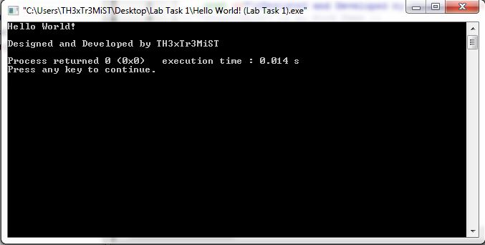

**Task 2):**

* **Write a program that displays your name and class number in the following format.**

**Name: Mr. XYZ**

**Class No: x**

**Code:**

|  |
| --- |
| #include <iostream>  using namespace std;  int main()  {  cout<<"Name: Muhammad Tousiq Wiqar Awan\n";  cout<<"Class number: 96"<<endl;  cout <<"\nDesigned and Developed by TH3xTr3MiST"<<endl;  // "TH3xTr3MiST" is my Nick Name :)  return 0;  } |

**Output:**

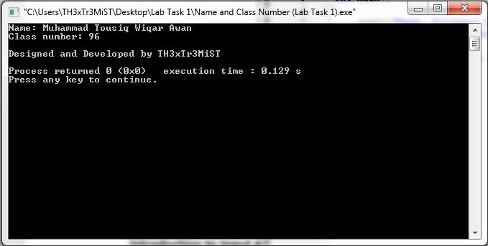

**Introduction to Input and Output functions**

**Task:**

* **Write a program that takes a number from the user and displays it.**

**Code:**

|  |
| --- |
| #include <iostream>  using namespace std;  int main()  {  int number;  cout<<"Enter a Number: ";  cin>>number;  cout<<"\nThe Number entered by the User is: "<<number<<endl;  cout <<"\nDesigned and Developed by TH3xTr3MiST"<<endl;  // "TH3xTr3MiST" is my Nick Name :)  return 0;  } |

**Output:**

**User Input: 10**

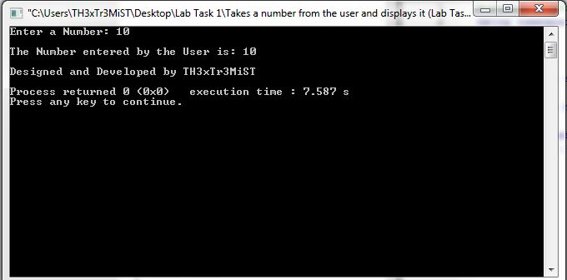

**Integer Arithmetic**

**Task 1):**

* **Write a program that adds 2 and 5 and displays the result**

**Code:**

|  |
| --- |
| #include <iostream>  using namespace std;  int main()  {  int num1 = 2, num2 = 5, sum;  sum=num1+num2;  cout<<"Sum of the Two pre-defined Numbers is: "<<sum<<endl;  cout <<"\nDesigned and Developed by TH3xTr3MiST"<<endl;  // "TH3xTr3MiST" is my Nick Name :)  return 0;  } |

**Output:**

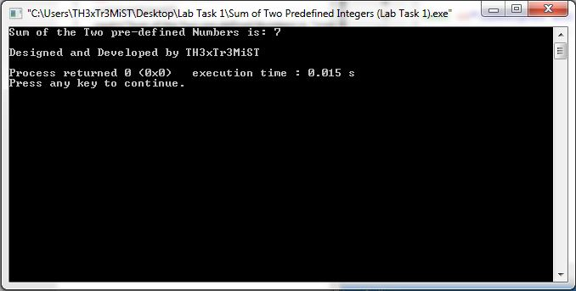

**Task 2):**

* **Write a program that takes two integer numbers from the user and performs the addition, subtraction, multiplication and division operations on them. Display all 4 outputs properly.**

**Code:**

|  |
| --- |
| #include <iostream>  using namespace std;  int main()  {  int num1, num2, sum, dif, mul, div;  cout<<"Enter the first number: ";  cin>>num1;  cout<<"Enter the second number: ";  cin>>num2;  sum=num1+num2;  cout<<"\nTheir Sum is: "<<sum<<endl;  dif=num1-num2;  cout<<"\nTheir Difference is: "<<dif<<endl;  div=num1/num2;  cout<<"\nTheir Quotient is: "<<div<<endl;  mul=num1*num2;  cout<<"\nTheir Product is: "<<mul<<endl;  cout <<"\nDesigned and Developed by TH3xTr3MiST"<<endl;  // "TH3xTr3MiST" is my Nick Name :)  return 0;  } |

**Output:**

**User Input:** 8 and 7

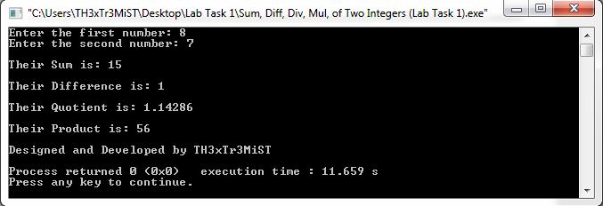

**Task 3):**

* **Write a program that takes the length and width of a rectangle from the user and displays its perimeter and area. (Note: Length and width can only be integers)**

**Code:**

|  |
| --- |
| #include <iostream>  using namespace std;  int main()  {  int length, width, parameter, area, rectangle;  cout<<"Enter the Length: ";  cin>>length;  cout<<"Enter the Width: ";  cin>>width;  parameter=(length*2) + (width*2);  cout<<"\nThe Parameter of the Rectangle is: "<<parameter<<endl;  area=length*width;  cout<<"\nArea of the Rectangle is: "<<area<<endl;  cout <<"\nDesigned and Developed by TH3xTr3MiST"<<endl;  // "TH3xTr3MiST" is my Nick Name :)  return 0;  } |

**Output:**

**User Input:**

* **Length:** 50
* **Width:** 20

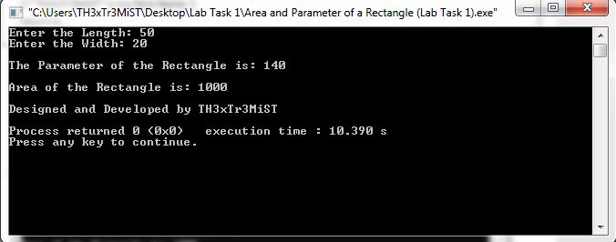

**Task 04:**

* **A: What is the value of *‘i’* (an integer variable) in the following expression? *i* = 2/3.**

**Answer:** 0

* **B: Is it ‘0’? If yes, Why?**

**Answer:** Because it is an integer and there are no decimals allowed.

**Operators Precedence**

**Task:**

* **Write down the outputs of the following expressions?   
  Compare your results with the C++ program.  
  *(Note: ‘i’ and ‘j’ are integer variables)***

1. ***i* = 2 + 3 ∗ 4 – 5**
2. ***i* = (2 + 3) ∗ 4 – 5**
3. ***i* = 2 + 3 ∗ (4 − 5)**
4. ***i* = 2 + (3 ∗ 4) – 5**
5. ***j* = 2 + 3 − 5 ∗ 6 + 7/3 + 100**
6. ***j* = 2 + (3 − 5) ∗ (6 + 7/3) + 100**
7. ***j* = 7 + 4 ∗ (9/(9 − 3 ∗ 2) + (7 ∗ (9 − 2 ∗ (8 + 1))))**

**C++ Program Output:**

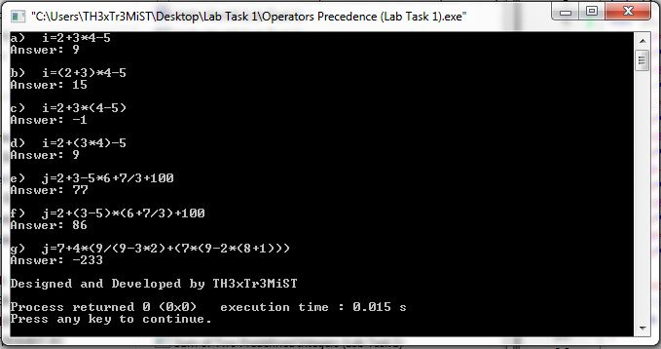

**Actual Answers:**

1. ***i* =** 9
2. ***i* =** 15
3. ***i* =** -1
4. ***i* =** 9
5. ***j* =** 232/3 or 77. $\dot{3}$ (repeating integer)
6. ***j* =** 256/3 or 85. $\dot{3}$ (repeating integer)
7. ***j* =** -233

**Comparing:**

|  |  |  |
| --- | --- | --- |
| **Equations** | **C++ Program Output** | **Actual Answers** |
| 2 + 3 ∗ 4 – 5 | 9 | 9 |
| (2 + 3) ∗ 4 – 5 | 15 | 15 |
| 2 + 3 ∗ (4 − 5) | -1 | -1 |
| 2 + (3 ∗ 4) – 5 | 9 | 9 |
| 2 + 3 − 5 ∗ 6 + 7/3 + 100 | 77 | 232/3 or 77. $\dot{3}$ |
| 2 + (3 − 5) ∗ (6 + 7/3) + 100 | 86 | 256/3 or 85. $\dot{3}$ |
| 7 + 4 ∗ (9/(9 − 3 ∗ 2) + (7 ∗ (9 − 2 ∗ (8 + 1)))) | -233 | -233 |

**Mod Operator (%)**

**Task 1):**

* **Write the output of the following expressions**

1. ***i* = 5%2**

**Output:** 1

1. ***i* = 57%3**

**Output:** 0

1. ***i* = 100%10**

**Output:** 0

**Program Output:**

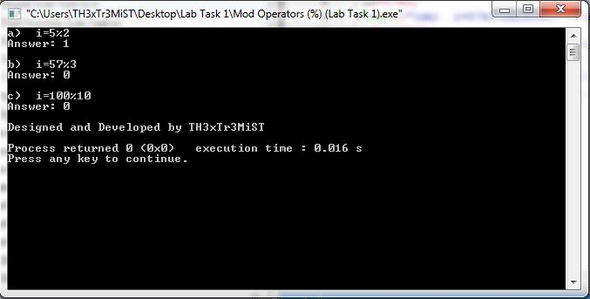

**Task 2):**

* **Write a program that takes a number from the user and displays its least   
  significant digit.**

**Code:**

|  |
| --- |
| #include <iostream>  using namespace std;  int main()  {  int number, least;  cout<<"Enter a Number: ";  cin>>number;  least=number%10;  cout<<"\nThe Least Digit Number is: "<<least<<endl;  cout <<"\nDesigned and Developed by TH3xTr3MiST"<<endl;  // "TH3xTr3MiST" is my Nick Name :)  return 0;  } |

**Output:**

**User Input:** 1709

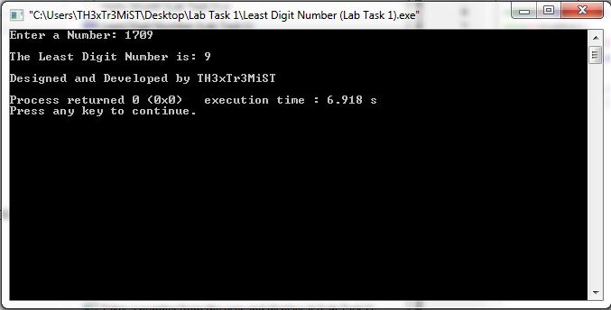

**Task 3):**

* **Write a program that takes seconds from the user and displays the time in Hours, minutes and seconds format. E.g. if the user enters 3700, the output of the program should be 1 Hour 1 minute and 40 seconds.**

**Code:**

|  |
| --- |
| #include <iostream>  using namespace std;  int main()  {  int time, minute, hour, sec;  cout<<"Enter Time: ";  cin>>time;  hour=time/3600;  minute=(time-hour*3600)/60;  sec=time%60;  cout<<"\nAnswer is: "<<hour<<" hours(s), "<<minute<<" minute(s) and "<<sec<<" seconds(s)."<<endl;  cout <<"\nDesigned and Developed by TH3xTr3MiST"<<endl;  // "TH3xTr3MiST" is my Nick Name :)  return 0;  } |

**Output:**

**User Input:** 3800

